Nombre: Curso:

WRITING TASK
WHAT DO THEY LOOK LIKE ?

Look at the photographs and describe the people as accurately as possible. Write about their eyes, hair, general appearance, complexion, height, age, etc. (when possible), using suitable nouns and adjectives and verbs BE and HAVE.

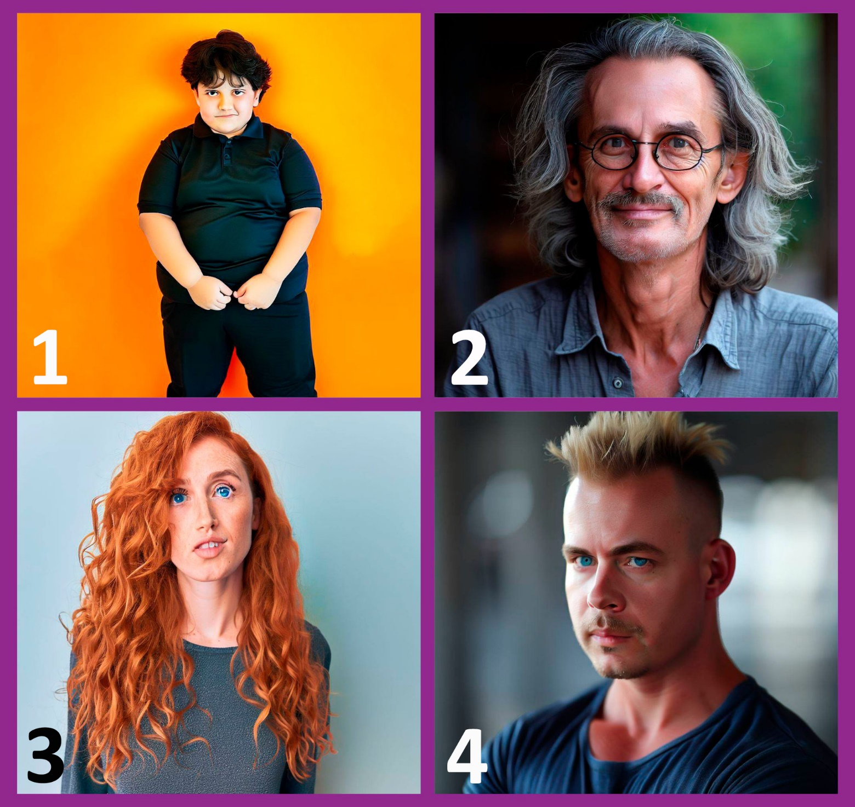
- MARTIN
…

- THOMAS
…

- REBECCA
…

- STEVEN
…

